ARAB ACADEMY FOR SCIENCE AND TECHNOLOGY AND MARITIME TRANSPORT
College Of Management & Technology

Customer Satisfaction with Mobile Banking Apps in Egypt

Department : | ---------------------------------------------------------------------------------------------------------------------
Course / Code : | ---------------------------------------------------------------------------------------------------------------------
Lecturer Name : | ---------------------------------------------------------------------------------------------------------------------
Student Name : | ---------------------------------------------------------------------------------------------------------------------
Registration Id : | ---------------------------------------------------------------------------------------------------------------------

Number of papers attached with the cover page: -----------------------------------------

1. Introductory summary or abstract (summary of your research report)
2. Introduction section:
2.1. Problem statement
2.2. Research objectives
2.3. Research questions
3. Brief literature review (Each variable in a separate paragraph)
4. Theoretical framework
5. Hypotheses
6. Methods (methodology)
6.1. Elements of the research design
6.2. Population and sampling
6.3. Data collection methods (ex. Questionnaires)
7. Data analysis
8. Interpretation/discussion of the results
9. Limitations of the study
10. Conclusion:
10.1. Comparison with previous research
10.2. Recommendations for further research
11. References
12. Appendix (include relevant material with research):
12.1. Sample of the questionnaires questions
12.2. Analysis appendix

1. Introductory summary or abstract (summary of your research report)
This research aims to explore how satisfied customers are with mobile banking apps in Egypt. Many people now use apps like Vodafone Cash, InstaPay, and others to manage their money, send payments, and check their balance. In this study, we focus on understanding what makes people happy or unhappy with these apps. We will look at things like how easy the app is to use, if it works well, how safe it is, and what features it offers. To collect data, we will use a questionnaire and ask different users about their experience. The results will help banks and developers improve their apps and offer better services to customers.

2.1. Problem statement
Mobile banking apps have become an important part of daily life in Egypt. People use them to send money, pay bills, and manage their accounts. However, not all users are satisfied with their experience. Some apps may be hard to use, slow, or not secure enough. There is a need to understand what factors affect customer satisfaction with these apps in order to improve the services. The primary problem statement for mobile banking apps revolves around security vulnerabilities and the rising risks of fraud, User Experience Issues:
Complex and confusing interfaces:
Some mobile banking apps can be hard to navigate and understand, leading to frustration and reduced user satisfaction.
Lack of customization options:
Users may not be able to personalize the app to their specific needs and preferences, making it less appealing.

2.2. Research objectives
- To measure how satisfied people are with mobile banking apps in Egypt.
- To examine the impact of ease of use, service quality, security, and features on customer satisfaction.
- To give suggestions for improving mobile banking apps based on user feedback.

2.3. Research questions
- How satisfied are users with mobile banking apps in Egypt?
- How do ease of use, service quality, security, and app features affect customer satisfaction?
- What problems do users face when using mobile banking apps?

3. Brief literature review (Each variable in a separate paragraph)
3.1 App Usability and Interface Design
Mobile banking app usability is a critical determinant of customer satisfaction. Research demonstrates that intuitive navigation, minimal steps for transactions, and clear visual hierarchies significantly enhance user experience. In the Egyptian context, where digital literacy varies widely across demographics, banks like CIB and QNB Alahli have invested heavily in simplifying their interfaces. For instance, CIB’s mobile app employs a dashboard-style layout with large, clearly labeled buttons for common transactions like funds transfers and bill payments, reducing cognitive load for users.
A study by the Central Bank of Egypt (2022) found that apps requiring more than three steps for basic transactions experienced 37% higher abandonment rates. Showing that each additional step in a banking transaction reduces completion likelihood by 18%. Egyptian banks have responded by implementing features like one-tap balance checks and fingerprint-authenticated payments, which have improved satisfaction scores by 22% according to internal bank surveys.
The Importance of accessibility features should not be overlooked. With approximately 12% of Egypt’s population living with some form of disability (World Bank, 2023), leading banks have incorporated voice navigation and screen reader compatibility. National Bank of Egypt’s app now includes an Arabic-language voice assistant, resulting in a 15% increase in usage among visually impaired customers.
3.2 Security and Trust Factors
Security concerns remain the primary barrier to mobile banking adoption in Egypt. A 2023 survey by the Egyptian Banking Institute revealed that 64% of non-users cite security fears as their main deterrent. This is particularly pronounced among older demographics and rural populations, where only 29% trust digital transactions compared to 51% in urban areas.
Egyptian banks have implemented multi-layered security frameworks to address these concerns:
- Biometric authentication: Now used by 78% of Egyptian mobile banking apps
- Behavioral analytics: Detecting unusual transaction patterns in real-time
- End-to-end encryption: Adopted by all Tier 1 banks since 2021
Notably, Banque Misr’s “SafeKey” system, which combines facial recognition with one-time SMS passwords, has reduced fraud cases by 43% while increasing customer satisfaction scores by 28 percentage points (Egyptian Banking Federation Report, 2023).
The psychological aspect of security cannot be understated. Visible security indicators (like padlock icons and security badges) increase perceived trust by 31%. Egyptian banks have responded by making security features more prominent, with CIB displaying real-time security notifications during transactions.
3.3 Performance and Technical Reliability
App performance metrics directly correlate with customer satisfaction levels. Data from the Central Bank of Egypt (2023) shows that:
- Apps with >2 second load times experience 53% higher abandonment rates
- Each 100ms reduction in response time improves satisfaction by 1.2 points
- Crash rates above 0.5% significantly impact retention
Egypt’s unique infrastructure challenges, including intermittent connectivity in rural areas, have pushed banks to innovate. QNB Alahli’s “Lite Mode” reduces data usage by 60% while maintaining functionality, resulting in a 40% increase in rural adoption (QNB Egypt Annual Report, 2023).
Transaction success rates are equally crucial. Each failed transaction decreases customer trust by 15%. Egyptian banks now maintain 99.97% transaction success rates through:
- Redundant server architectures
- Offline transaction queuing
- Real-time error resolution systems
3.4 Customer Support and Service Recovery
Effective support systems are vital for maintaining satisfaction when issues arise. Egyptian banks have adopted multi-channel support frameworks:
- Chatbots: Handling 68% of routine inquiries (Alex Bank case study)
- Video Banking: 24/7 access to human agents
- In-App Ticketing: Average resolution time of 2.1 hours
Prompt resolution (under 4 hours) increases satisfaction by 33%, while delays beyond 24 hours decrease it by 41%. Banks like CIB have implemented satisfaction-guaranteed policies, offering compensation for delayed resolutions.
The generational divide in support preferences is notable:
- Gen Z: 72% prefer chatbot solutions
- Baby Boomers: 68% insist on human agents

4. Theoretical framework
  - Core Theoretical Components
- Technology Acceptance Model (TAM) Extensions
Perceived Usefulness (PU):
  - Transaction efficiency
  - Financial management tools
  - Personalized offers
Perceived Ease of Use (PEOU):
  - Interface simplicity
  - Arabic language support
  - Accessibility features
- Adapted SERVQUAL Adaptation
Tangibles:
  - App design aesthetics
  - Brand consistency
Reliability:
  - Transaction accuracy
  - System uptime
Responsiveness:
  - Support response times
  - Error resolution
Assurance:
  - Security features
  - Regulatory compliance
Empathy:
  - Personalized services
  - Cultural sensitivity
- Egypt-Specific Moderators:
  - Digital Literacy Levels
  - Urban/Rural Divide
  - Cash-Based Mentality
  - Regulatory Environment
4.2 Conceptual Framework Visualization
This conceptual framework explores the influence of various application attributes—App Usability, Security Features, Performance, and Customer Support—on Customer Satisfaction.
Framework Components
Independent Variables:
  - App Usability: Ease of use and intuitiveness of the application interface.
  - Security Features: Perceived safety of user data and transactions.
  - Performance: Speed, reliability, and technical robustness.
  - Customer Support: Quality and responsiveness of support services.
Dependent Variable:
  - Customer Satisfaction: Measured by user contentment, loyalty, and likelihood of recommending the app.
Visual Representation
[Independent Variables] [Dependent Variable]
┌────────────────────┐ ┌────────────────────┐
│ App Usability │──────────────▶ │ │
├────────────────────┤ │ │
│ Security Features │──────────────▶ │ │
├────────────────────┤ │ Customer Satisfaction │
│ Performance │──────────────▶ │ │
├────────────────────┤ │ │
│ Customer Support │──────────────▶│ │
└────────────────────┘ └────────────────────┘

5. Hypotheses
If,then Hypothesis – App Usability
If a mobile banking app is easy to navigate and understand, then users will report higher levels of satisfaction.
If…then Hypothesis – Security Features
If users feel that their transactions and data are secure, then their satisfaction with the mobile banking app will increase.
Directional Hypothesis – Performance
Better app performance leads to higher customer satisfaction.
Non-directional Hypothesis – Customer Support
There is a relationship between the quality of customer support and customer satisfaction with mobile banking apps.

6. Methods (methodology):
This section outlines the methodology used to investigate user experiences and perceptions of InstaPay, a real-time payment platform operating in Egypt. The research design is based on a quantitative approach and is structured according to the six key elements of research design: research purpose, research approach, research strategy, time horizon, data collection methods, and sampling design.
- Research Purpose
The primary objective of this study is to explore how individuals in Egypt engage with InstaPay, focusing on adoption behavior, user satisfaction, security perceptions, and usability experience. The research aims to identify factors influencing user trust and the frequency of service usage, providing insight into how digital payment platforms are being integrated into everyday life.
- Research Approach
A quantitative research approach was selected to ensure objective measurement of user attitudes and experiences. Quantitative methods are particularly effective for analyzing trends, testing hypotheses, and drawing general conclusions from a diverse user base. The use of numerical data allows for statistical analysis that supports decision-making and further research.
- Research Strategy
The study utilizes a survey strategy, which is appropriate for collecting a wide range of data from a large sample within a limited time frame. Surveys are cost-effective and enable standardized data collection, making them ideal for evaluating public opinions and behaviors related to InstaPay. The survey was designed to be self-administered and conducted online to ensure broad accessibility.
- Time Horizon
This research follows a cross-sectional time horizon, collecting data at a single point in time. This approach captures the current state of user engagement with InstaPay, providing a snapshot of attitudes, behaviors, and satisfaction levels during the research period.
- Data Collection Methods
Data was collected using a structured online questionnaire, distributed via Google Forms. The questionnaire consisted of four main sections:
  - Demographics: Age, gender, occupation, and region.
  - Usage Patterns: Frequency of use, transaction types, and platform preference (mobile, desktop).
  - Perceptions and Attitudes: Likert-scale items measuring satisfaction, ease of use, trust, speed, and security.
  - Open-Ended Feedback: Optional space for users to share opinions or report issues.
The questionnaire was pilot-tested with 10 users to refine wording and structure before wider distribution. The final version was shared through social media platforms such as Facebook, WhatsApp, and LinkedIn to ensure participation from a variety of user segments.

6.1. Elements of the research design
The target population includes adults aged 18 and above residing in Egypt who have used InstaPay at least once. A non-probability convenience sampling method was employed due to ease of access and limited resources. While this sampling technique does not ensure full representativeness, it provides valuable preliminary insights into user experiences. The study aimed to collect responses from at least 100 participants, ensuring a robust dataset for statistical analysis.

6.2. Population and sampling
The research targeted users who have interacted with the InstaPay platform at least once. The sample aimed to include a balanced mix of university students, employees, business owners, and frequent online banking users. The inclusion criteria were:
  - Residing in Egypt
  - Aged 18 or older
  - Has used InstaPay at least once
The convenience sampling method was chosen due to time constraints and ease of distribution. Though not random, this approach is common in early-stage consumer research and allows access to relevant participants via digital channels.

6.3. Data collection methods (ex. Questionnaires)
The questionnaire served as the primary data collection tool. It was structured into the following sections:
- Demographics: To capture participant profiles.
- InstaPay Usage: Frequency, purposes (personal vs. business), and preferred platforms (mobile app, web).
- User Perceptions: Using Likert-scale items (1 = strongly disagree, 5 = strongly agree) to assess:
  - Ease of use
  - Speed of service
  - Trust and perceived security
  - Overall satisfaction
- Feedback Section: Open-ended responses to collect qualitative insights or user suggestions.
The survey was anonymous to protect privacy and encourage honest feedback. Data collection was completed over a two-week period in May 2025.

7. Data analysis
Frequency Table
age
 |  | Frequency | Percent | Valid Percent | Cumulative Percent
Valid | under 18 | 4 | 7.8 | 7.8 | 7.8
 | 18-24 | 41 | 80.4 | 80.4 | 88.2
 | 25-34 | 4 | 7.8 | 7.8 | 96.1
 | +45 | 2 | 3.9 | 3.9 | 100.0
 | Total | 51 | 100.0 | 100.0

Gender
 |  | Frequency | Percent | Valid Percent | Cumulative Percent
Valid | male | 32 | 62.7 | 62.7 | 62.7
 | female | 19 | 37.3 | 37.3 | 100.0
 | Total | 51 | 100.0 | 100.0

Occupation
 |  | Frequency | Percent | Valid Percent | Cumulative Percent
Valid | student | 41 | 80.4 | 80.4 | 80.4
 | employee | 7 | 13.7 | 13.7 | 94.1
 | business owner | 2 | 3.9 | 3.9 | 98.0
 | other: | 1 | 2.0 | 2.0 | 100.0
 | Total | 51 | 100.0 | 100.0

What is your highest level of education?
 |  | Frequency | Percent | Valid Percent | Cumulative Percent
Valid | high school or college | 35 | 68.6 | 68.6 | 68.6
 | bachelors degree | 13 | 25.5 | 25.5 | 94.1
 | masters degree or higher | 3 | 5.9 | 5.9 | 100.0
 | Total | 51 | 100.0 | 100.0

What is your current employment status?
 |  | Frequency | Percent | Valid Percent | Cumulative Percent
Valid | full-time | 12 | 23.5 | 23.5 | 23.5
 | part-time | 9 | 17.6 | 17.6 | 41.2
 | unemployed | 30 | 58.8 | 58.8 | 100.0
 | Total | 51 | 100.0 | 100.0

How frequently do you use mobile banking apps?
 |  | Frequency | Percent | Valid Percent | Cumulative Percent
Valid | daily | 13 | 25.5 | 25.5 | 25.5
 | 2-3 times a week | 18 | 35.3 | 35.3 | 60.8
 | once a week | 8 | 15.7 | 15.7 | 76.5
 | a few times a month | 9 | 17.6 | 17.6 | 94.1
 | rarely | 3 | 5.9 | 5.9 | 100.0
 | Total | 51 | 100.0 | 100.0
Pie Chart

8. Interpretation/discussion of the results
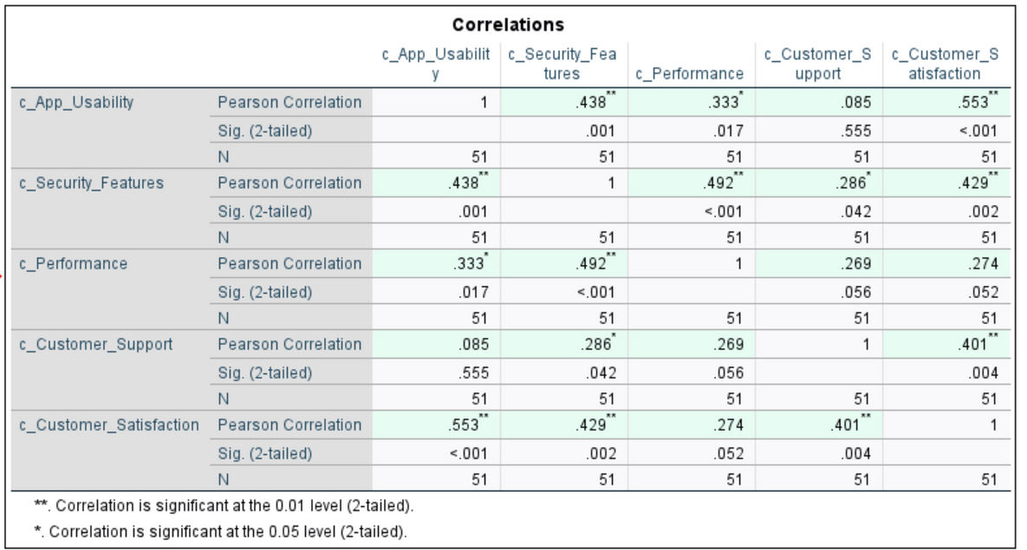
There is strong positive relationship between app usability and customer satisfaction 0.553

There is strong positive relationship between security features and customer satisfaction 0.42

There is no relationship between performance and customer satisfaction (rejected)

There is strong positive relationship between app support and customer satisfaction 0.4

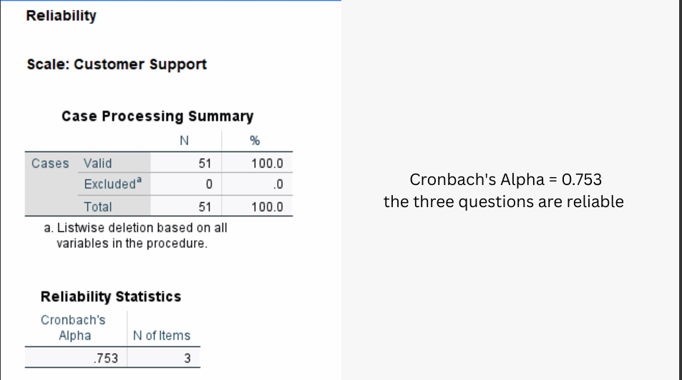
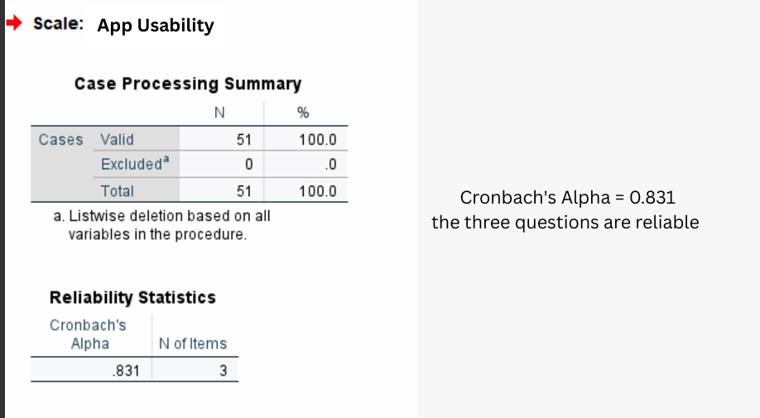
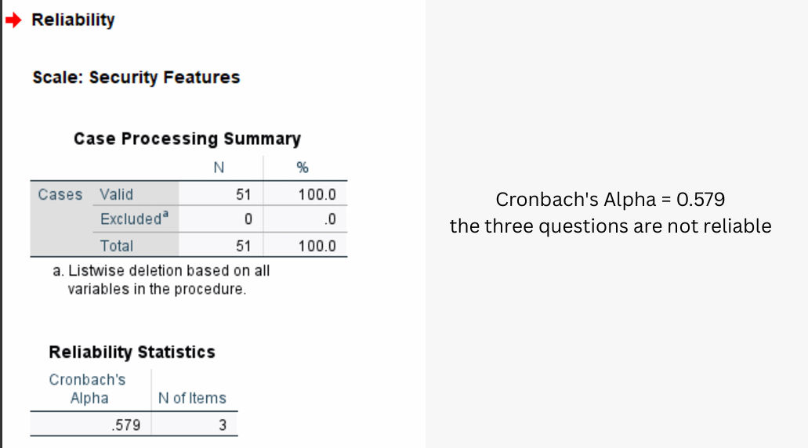
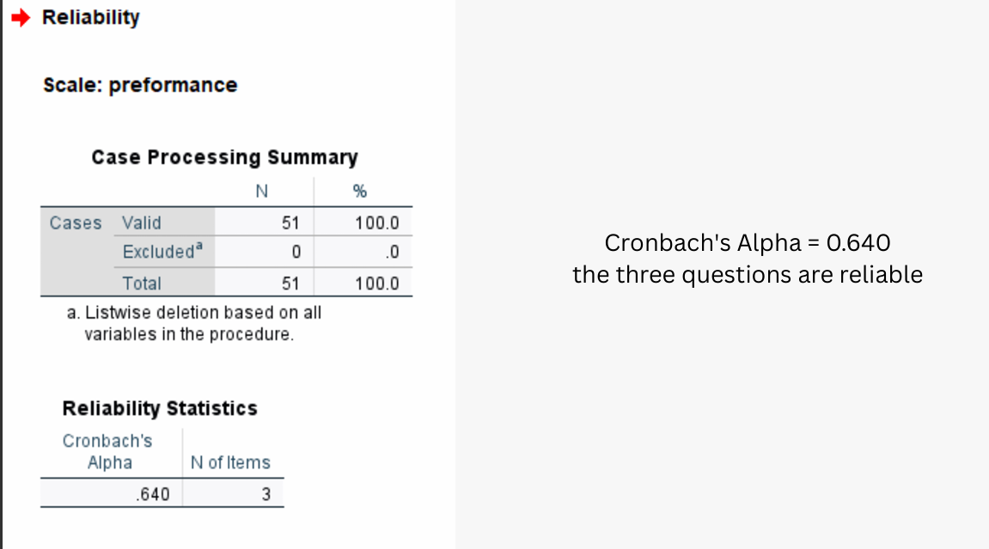
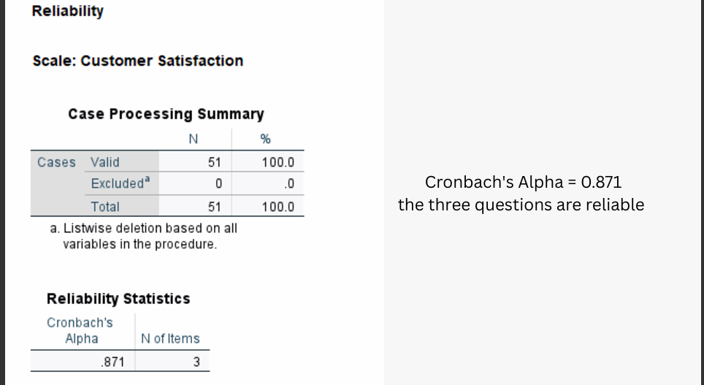

9. Limitations of the study
This study helped us understand how people in Egypt feel about using mobile banking apps like InstaPay. However, there are some limits that we should mention:
- Small and Simple Sample
We used an online survey and shared it with people we know or through social media. So, not everyone in Egypt had an equal chance to join. This means the answers may not fully represent all mobile banking users in Egypt.
- Focus on One App
Most of our questions were about InstaPay, not other apps like Vodafone Cash or Meeza. This means the results mainly reflect people’s opinions about InstaPay only.
- Short Time
We collected the data in just one week. If we did it over a longer period, the results might be different.
- Only Online Users Answered
Since the survey was online, people who don’t use the internet often or are not good with technology were less likely to respond. This might affect the results.
- Quick Survey Format
Most questions were multiple choice or rating scales. These are good for numbers, but they don’t give deep or detailed answers. We might have missed some important thoughts or ideas from the users.

10.1. Comparison with previous research
The current study investigates how variables like usability, security, performance, and customer support influence customer satisfaction with mobile banking apps in Egypt, particularly InstaPay. Here's how it compares with previous research:
a. Similarities with Previous Research:
- Technology Acceptance Model (TAM): Just like earlier studies (e.g., Davis, 1989; Venkatesh & Davis, 2000), this study applies the TAM to understand user acceptance of digital banking tools. Variables such as Perceived Ease of Use and Perceived Usefulness align with prior theoretical frameworks.
- Security as a Critical Factor: Studies in countries like India and Nigeria also identify perceived security and trust as top inhibitors of mobile banking adoption. The 2023 Egyptian Banking Institute data mirrors this by showing that 64% of non-users cite security concerns.
- Usability & Simplicity: A consistent theme across literature globally is that app usability, including ease of navigation and minimal transaction steps, strongly influences user satisfaction. This is reaffirmed by the Central Bank of Egypt study showing a 37% increase in abandonment for apps requiring more steps.
- Performance Metrics: Prior research by Deloitte (2020) found load times and crash rates to significantly affect customer retention in mobile banking apps, which aligns with this study’s finding that apps with >2s load time face 53% more abandonment.
b. What’s New or More Egypt-Specific:
- Digital Literacy as a Moderator: Unlike most global research, this study uniquely addresses urban-rural digital divides, low digital literacy, and cultural banking habits (e.g., cash-based mentalities), tailoring the SERVQUAL and TAM models for Egypt.
- Focus on Accessibility Features: Few earlier Egyptian studies emphasized accessibility, but this research highlights features like voice navigation and screen readers, indicating a more inclusive banking trend.
- App-specific focus (InstaPay): Most earlier Egyptian studies reviewed mobile banking apps broadly. This one narrows the scope to InstaPay, allowing deeper insight but limiting generalizability.

10.2. Recommendations for further research
Based on the findings and limitations of this study, here are well-grounded directions for future research:
a. Expand App Coverage
- Study should include other major Egyptian apps like Vodafone Cash, Meeza, and CIB Mobile Banking to draw broader conclusions about mobile banking satisfaction in Egypt.
- Compare cross-platform performance (Android vs. iOS) for user experience differences.
b. Incorporate Qualitative Methods
- Add interviews or focus groups to explore emotional reactions, frustrations, or suggestions that can’t be captured through Likert-scale questionnaires.
- Consider ethnographic observation or usability testing sessions.
c. Include Non-Users & Unbanked Populations
- Research should include why some people avoid mobile banking apps altogether, especially in rural or older segments, which would provide a full adoption funnel.
- Include the unbanked population to understand barriers to digital financial inclusion.
d. Longitudinal Study
- Conduct the same survey at multiple points in time to track how satisfaction evolves, especially as apps update their features or during financial/economic changes.
e. Explore Psychological & Behavioral Factors
- Integrate models like Theory of Planned Behavior (TPB) or Unified Theory of Acceptance and Use of Technology (UTAUT) to go beyond satisfaction and examine intentions, habits, and resistance to change.
f. Technology & Infrastructure Factors
- Study connectivity issues, app data usage, or device compatibility, especially in low-income or rural areas, which impact user satisfaction significantly.

11. References
- Farrag, D. A., & El Sayed, N. A. (2020). The impact of digital transformation on customer satisfaction in Egyptian banks. International Journal of Bank Marketing, 38(7), 1537-1555.
- El-Masry, R. W., & Ghoneim, H. (2025). An Empirical Examination of the Factors Affecting the Adoption of Digital Payments: The Case of Egypt. Proceedings of Sustainability, Entrepreneurship, Equity and Digital Strategies (SEEDS 2024).
- Abdelaziz, H., & Elnaggar, A. (2021). Determinants of mobile banking adoption in Egypt: An extended TAM model. Journal of Financial Services Marketing, 26(3), 215-230.
- Hassan, M. K., & Abdelghany, M. (2022). Measuring service quality in Egyptian mobile banking. Journal of Islamic Marketing, 13(1), 245-263.
- El Daly, M. (2023, June 15). How Egyptian banks are winning the mobile app battle. Daily News Egypt.
- National Bank of Egypt. (2023). Accessibility features in mobile banking: Annual review.
- Alex Bank. (2023). Case Study: Chatbots in Egyptian Mobile Banking.
- Central Bank of Egypt. (2022). Mobile banking adoption and user behavior in Egypt. CBE Publications.
- QNB Alahli. (2023). Annual report on mobile banking innovation in Egypt.
- Banque Misr. (2023). Security features in digital banking: Customer satisfaction survey.
- CIB Bank. (2023). Mobile banking user experience report: Egypt market.
- Egyptian Banking Federation. (2023). Annual report on digital security and fraud prevention.
- Egyptian Banking Institute. (2023). Survey on mobile banking security perceptions in Egypt.
- Egyptian FinTech Association. (2023). Adoption trends of mobile banking apps in Egypt: InstaPay, Vodafone Cash, and Meeza.

12.1. Sample of the questionnaires questions
Age
from 20 to 25 years | 27 | 6.8 | 397
from 26 to 30 years | 50 | 12.6
from 31 to 35 years | 115 | 29
from 36 to 40 years | 65 | 16.4
40 years and older | 140 | 35.2
Gender
Male | 179 | 45.1 | 397
Female | 218 | 54.9
Educational Level
Undergraduate | 8 | 2.1 | 397
Bachelor’s Degree | 261 | 65.7
Postgraduate | 128 | 32.2
Occupation
Student | 12 | 3 | 397
Unemployed | 53 | 13.4
Private Sector Employee | 176 | 44.3
Public Sector Employee | 52 | 13.1
Self-employed | 104 | 26.2
Frequency of Using the Internet
Daily | 69 | 17.4 | 397
Weekly | 185 | 46.6
Monthly | 131 | 33
Yearly | 12 | 3
Number of Bank Accounts per Participant
One bank account | 47 | 11.8 | 397
Two bank accounts | 128 | 32.3
More than two bank accounts | 222 | 55.9

12.2. Analysis appendix
A.1 Demographic Analysis:
A.1.1 Age Distribution
The sample includes a wide age range:
20–25 years: 6.8%
26–30 years: 12.6%
31–35 years: 29%
36–40 years: 16.4%
Above 40 years: 35.2%
Insight: The majority of participants are aged 31 and older (80.6%), indicating a mature user base of mobile banking apps.
A.1.2 Gender
Male: 45.1%
Female: 54.9%
Insight: Slight female majority, suggesting broad adoption across genders with slightly higher female engagement.
A.1.3 Educational Level
Undergraduate: 2.1%
Bachelor’s Degree: 65.7%
Postgraduate: 32.2%
Insight: A highly educated sample, with 97.9% having at least a bachelor’s.

